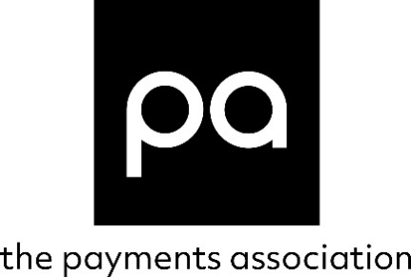

ECOSYSTEM STRATEGY SPRINT QUESTIONS

Submitted by:
Company name:
Choose one of the following: ASPSP/TPP/TSP OR OTHER
Contact Details:
email & mobile

As set out in its Terms of Reference, the Strategic Working Group (SWG) is expected to produce a report setting out views on how Open Banking should be developed beyond its current requirements, why certain priorities should be considered, and what the suggested costs and benefits are of the proposals put forward for the Joint Regulatory Oversight Committee’s consideration (Committee).

We welcome evidence-based responses to the questions posed by the Committee. Please complete your responses in the box below each question in Word format. Written submissions will not be attributed to you, your firm or association and will be presented in any report on an anonymous basis unless otherwise requested by the contributor.

Where you wish to provide supporting evidence, please embed these or the links to them in the Appendix. Please do not email them as attachments.

Rules and standards

QUESTION 1:

What Are there any gaps in current guidance and standards to ensure efficient and safe customer journeys and support broader use cases? If so, what is missing and what needs to be changed?

QUESTION 2:

Is there a need to improve API availability and performance? What is the evidence and how could it be addressed?

QUESTION 3:

What areas would multilateral agreements and updated standards covering services beyond the Order and existing regulations need to cover in order to facilitate continued development of open banking in a safe and efficient manner? Why?

QUESTION 4:

Are there blockers in developing multilateral agreements? Please provide rationale and evidence. Who should be responsible for administering, ensuring compliance with, and taking forward future changes to such agreements?

QUESTION 5:

Identify current gaps and identify what may be needed to put in place effective dispute management, redress and resolution mechanisms and processes across ecosystem participants, e.g., between ASPSPs and TPPs, between end-users and ASPSPs and TPPs

QUESTION 6:

Discuss and consider the development of a crisis management strategy and plan.

Trusted ecosystem with visibility and clarity of roles

QUESTION 7:

Is something needed to further strengthen consumers and other end users' trust in open banking? Should tools such as trust marks be considered or not? Please provide rationale and evidence.

QUESTION 8:

Are further tools or guidance needed (or not) to increase consumer understanding and awareness, including in considering consent management? Please provide rationale and evidence.

QUESTION 9:

How can we improve the visibility over onward sharing? What is needed? (while taking into account the implication of GDPR and development of smart data legislation)

QUESTION 10:

What needs to be done to define and clarify the roles and inter-relationships of key players in the ecosystem, including firms the information is onward shared with, as well as Pay.UK and retailers?

QUESTION 11:

What capabilities/functionalities are needed for the ongoing successful operation of open banking? What may need to be provided centrally by the future entity (or another entity) versus distributed? Please provide rationale and evidence.

ADDITIONAL COMMENTARY:
Please add additional commentary if there are topics which respondents feel would warrant consideration by the Committee. Please provide rationale and evidence.

Appendix – Supporting Evidence

