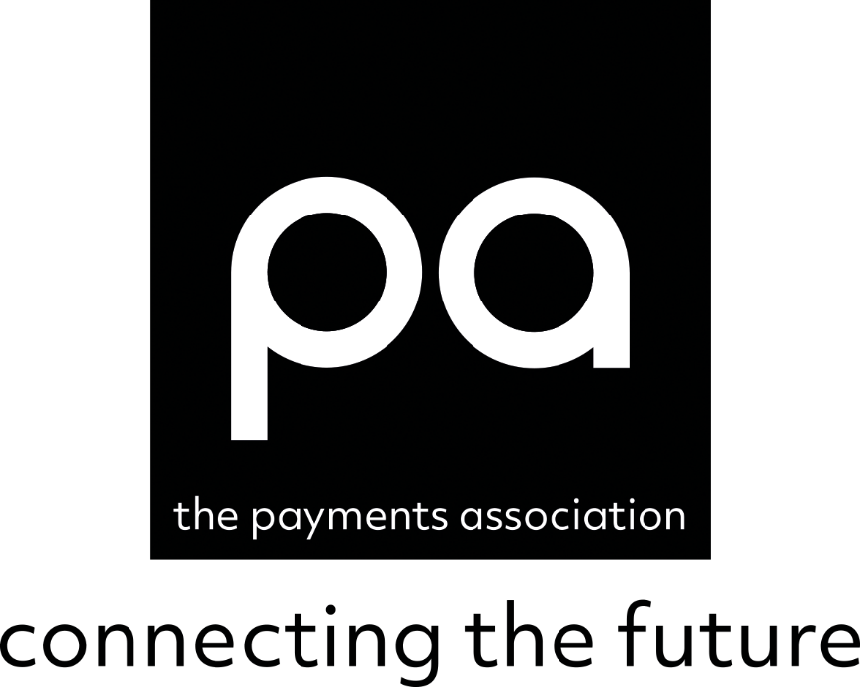

Crypto Industry – Call for Evidence

Treasury Committee

September 2022

Response from The Payments Association

Introduction

The Payments Association welcomes the opportunity to contribute to the Treasury Committee “Crypto Industry – Call for Evidence”.

The community’s response contained in this paper reflects views expressed by our members and industry experts recommended by them who have been interviewed and who are referenced below. As The Payment Association’s membership includes a wide range of companies from across the payments value chain, and diverse viewpoints across all job roles, this response cannot and does not claim to fully represent the views of all members.

We are grateful to the contributors to this response, which has been drafted by Riccardo Tordera, our Head of Policy & Government Relations. We would also like to express our thanks to the Treasury Committee for their continuing openness in these discussions. We hope it advances our collective efforts to ensure that the UK’s payments industry continues to be progressive, world-leading and secure, and effective at serving the needs of everyone who pays and gets paid.

With special thanks to:
- Robert Courtneidge – TPA Policy Adviser

Tony Craddock
Director General
The Payments Association

Contents

The section numbering below responds to the invitation to provide views on the following areas of interest:

- To what extent are crypto-assets when used as digital currencies (such as Stablecoin) likely to replace traditional currencies?

In developed markets, traditional cryptocurrencies such as Bitcoin and Ethereum will likely be used as commodities, stocks and shares but won’t become a means of payments because of their volatility and the lack of merchant infrastructure to enable real time payments when compared with current payments methods such as cards and mobile payments. Nonetheless, stablecoins, because of their peg to traditional currencies, could in future be seen as a useful means of exchange once the necessary infrastructure is in place to make payments seamless.

In underdeveloped markets, where local currencies are per se volatile and there is little or payments infrastructure in place, the ability to make peer-to-peer payments on the blockchain may be appealing and concretise in what we can observe in countries such as El Salvador where Bitcoin is now a legal tender.

At a global level, should big tech companies such as Google, Apple, Facebook and Amazon create their own stablecoin (as Facebook tried to do with Libra/Diem), this could become the equivalent of a new unregulated global central bank, and it is this scenario that governments and central banks around the world are trying to manage through regulation to avoid them replacing traditional currencies.

It is important to reference here that CBDCs, whilst being created in a similar way to stablecoins, are nothing less than traditional currencies, but in digital form.

- What opportunities and risks would the introduction of a Bank of England Digital Currency bring?

Along with a number of our members, including Boston Consulting Group and paywith.glass, this February we released a Green Paper entitled “New Era for Money”, which set out our views on a UK CBDC covering points a), b), and c) above, which has already been shared with you.

Further, we are supporting the Pilot which has resulted from the Green Paper and is due to commence in October this year to test and validate the potential use cases. The Pilot is being run by the Digital FMI Consortium (https://www.digitalfmi.com/) who have also produced a response to this Inquiry.

- What impact could the use of crypto-assets have on social inclusion?

In developed countries, such as the UK, where payments systems are highly integrated across all socio-economic groups, there is limited additional benefits immediately available from using crypto-assets. This because social inclusion has been achieved to a very large extent by the current payments infrastructure. However, even in developed countries we still have some digital exclusion because of insufficient infrastructure (broadband and mobile signal coverage). Hence, physical cash remains the only option to avoid exclusion and digital assets would not be of any help.

In underdeveloped countries, with low levels of payments infrastructure, a move to peer-to-peer payments on the blockchain can be seen as a natural solution to quickly gain traction and create financial inclusion. An example of a peer-to-peer system that has worked successfully is the mobile money service M-Pesa that started in Kenya and is now providing more than 51 million customers access to payments across seven countries in Africa, with over 314bn USD in transactions per year.

- Are the Government and regulators suitably equipped to grasp the opportunities presented by crypto-assets, whilst at the same time mitigating against the risks?

Whilst the private sector is moving fast, the public sector seems unable to move at the same speed. This is may be due to the lack of knowledge and adequate resources needed to keep up with innovation in this extremely fast moving environment. A public-private initiative would in our view solve this problem and help the UK to create the best possible framework to grasp the opportunities and mitigate against the associated risks, in the development of this industry at both a domestic and international level.

- What opportunities and risks could the use of crypto-assets-including Non-Fungible Tokens-pose for individuals, the economy, and the workings of both the public and private sectors?

In terms of opportunities:
- For individuals – the programmability of crypto assets could create benefits in relation to consumer protection and open banking solutions as well as the use of NFTs ensures provenance in the acquisition of goods. The growing use of NFTs in the media industry for downloads of music, videos, etc is increasing consumers’ choice and reducing costs.
- For the economy – new sources of revenues for the government in the form of smart taxation, attract inward investments in the UK, and create new jobs.
- For public and private sectors – we envisage many public/private sector initiatives developing in this area for the benefit of both

In terms of risks:
- For individuals – lack of education exposes consumers to new forms of fraud, phishing attacks and cyber crime
- For the economy – financial stability issues caused by the collapse of some forms of crypto that became systemic without appropriate checks and balances being in place
- For public and private sectors – not being at the forefront of innovation and lose competitiveness in the international market

- How can distributed ledger technology be applied in the financial services sector?

We see the programmability of CBDCs and stablecoins being a key factor in enabling seamless payments solutions both nationally and internationally. Further, digital finance will be able to rely on DLT to create appropriate solutions for digital identity that will improve the ability to deliver AML and CTF.

- What work has the Government (and its associated bodies) done to understand, prepare for and, where relevant, encourage changes that may be brought about by increased adoption of crypto-assets?

We welcome the announcement made by the former Chancellor Rishi Sunak to make the UK the global hub for crypto assets and the various consultations that have been coming through from HMT, the FCA and other bodies as we believe that good new regulation is required to help this industry flourish in the UK.

However, we observe a mismatch between the goal of becoming a global hub for crypto investment and the measures put in place. All the consultations that are coming through seem to respond to specific issues without being part of a wider strategy that sets clear objectives and designs the appropriate framework to achieve them.

- How might the Government's processes - for instance the tax system - adapt should crypto-assets be adopted more widely?

Trying to adapt existing laws to crypto will not work. Taxes on crypto have to be thought through on the basis of a deep understanding of how crypto work. The creation of smart new taxes that fit the peculiarities of the new asset classes is the way forward to help the industry grow and remain attractive in a global environment where competition in tax systems could push crypto money to leave the UK in favour of countries such as Portugal that have already created a better tax environment for crypto.

- How effective have the regulatory measures introduced by the Government - for instance around advertising and money laundering - been in increasing consumer protection around crypto-assets?

Advertising: the change in financial promotion regulation to encompass crypto advertising has clearly had the positive outcome of stopping bad actors advertising their scams, nonetheless it has caused the unintended consequence of closing down all crypto advertising. This is the only specific crypto-led regulation currently in place other than traditional financial crime regulations. Urgent action should be taken to tackle these issues, while enabling the facilitation of the UK as the global crypto hub.

Money laundering: since the FCA introduced the registration process for crypto businesses in the UK, it has faced numerous delays due to shortages of sufficiently qualified staff to run the registration process and it faced criticism from the industry not only for being slow but also because many companies do not believe they have had clear enough explanations as to why their applications have been rejected. Whilst we appreciate having high standards in place, we still wish for the UK to become the number one hub for this industry, while providing the right balance between industry growth and consumer protection.

- Is the Government striking the right balance between regulating crypto-assets to provide adequate protection for consumers and businesses and not stifling innovation?

Currently there is no regulation on crypto-assets other than as set out in the previous question. The consultations going through currently are looking to create new regulation in this space and we would hope that the resulting regulations coming out of this process will create the right balance.

- Could regulation benefit crypto-asset start-ups by improving consumer trust and resilience?

We advocate smart good regulation to ensure that this is possible.

- How are Governments and regulators in other countries approaching crypto-assets, and what lessons can the UK learn from overseas?

We are aware that many territories around the world are looking to create regulation in this space, both as a means of protecting their financial stability whilst also providing a good environment for innovation. The EU’s Markets in Crypto-Assets regulation (MiCA) has already received approval and will come into force in October 2024: the risk of the UK being slow at developing its own regulation could result in being effectively left behind. We urge HM Government to lead in this space and we would welcome the opportunity to assist them in any way we can.

More generally, digital assets are likely to become the next battleground in the geopolitical sphere because in the near future what matters will not be about reserve currencies but about digital financial markets infrastructure (dFMI). China has already assumed global CBDC leadership and could use its Belt & Road Initiative (BRI) as a dFMI launchpad. However, the opportunity of designing a UK CBDC could offer an alternative dFMI launchpad to those countries that do not want or can resist the Chinese model. Indeed, the UK could lead this development and collaborate with the other nations of the Commonwealth.

- The environmental and resource intensity of using crypto-asset technology.

Cryto-asset technology is an easy target for criticism as it is easy to calculate the cost in terms of energy in running blockchain solutions unlike the multiple players and costs involved in legacy banking systems which are almost impossible to calculate. Bitcoin mining, for example, has been criticised because of the high energy consumption required to keep the Bitcoin network running. However Bitcoin mining is becoming increasingly green as it encourages the development of more efficient renewable energy solutions. According to a Q4/2021 report from the Bitcoin Mining Council (BMC), Bitcoin mining uses “a higher mix of sustainable energy than any major country or industry in the world.”

In addition, there are a number of initiatives around the world looking to make the crypto industry carbon neutral. These include:
- the Crypto Climate Accord working towards creating a 100% carbon neutral crypto industry by 2030;
- Energy Web and Ripple partnering to build EW Zero, “an open-source tool that will enable any blockchain to decarbonize through the purchase of renewable energy in local markets worldwide.”; and
- Binance and the International Rec Standard partnering to establish the Green Bitcoin Project. The project offers “a fully transparent purchasing of renewable energy certificates (REC) to manage and track energy consumed from renewable power sources, as RECs are legal proof that energy has been generated from renewable electricity sources like solar or wind power.”

As such it is our view that the transparency of crypto-asset technology, in respect of its impact on the environment and intensity of use of resources, will enable it to become more sustainable than any other form of payment system.

About The Payments Association

The Payments Association (previously the Emerging Payments Association, or EPA) is a community for all companies in payments, whatever their size, capability, location or regulatory status. Its purpose is to empower the most influential community in payments, where the connections, collaboration and learning shape an industry that works for all. It works closely with industry stakeholders such as the Bank of England, the FCA, HM Treasury, the PSR, Pay.UK, UK Finance and Innovate Finance.

Through its comprehensive programme of activities and with guidance from an independent Advisory Board of leading payments CEOs, The Payments Association facilitates the connections and builds the bridges that join the ecosystem together and make it stronger. These activities include a programme of monthly digital and face-to-face events including an annual conference, PAY360, The PAY360 Awards dinner, CEO round tables and training activities. The Payments Association also runs six stakeholder working project groups covering financial inclusion, regulation, financial crime, cross-border payments, open banking and digital currencies. The volunteers in these groups represent the collective views of the industry and work together to ensure the big problems facing the industry are addressed effectively. The association also conducts original research which is made available to members and the authorities. These include monthly whitepapers, insightful interviews, and tips from the industry’s most successful CEOs.

See www.thepaymentsassociation.org for more information. Contact malik.smith@thepaymentsassociation.org for assistance.

